Committee on Curriculum and Instruction
Approved Minutes

April 9, 2010 9:00 AM-11:00 AM

Physics Research Building Conference Room 4138

ATTENDEES: Andereck, Daniels, David, Gustafson, Hallihan, Harvey, Highley, Huffman, Masters, Meyers, Mumy, Shabad, Vaessin, Vankeerbergen, Williams
Guests: J. Cataldi

Agenda

1. Arts Entrepreneurship New Minor (Guest: Jane Cataldi)
- Overview by J. Cataldi (Dept of Art Education).
- Visual Arts is primary program of Dept of Art Education (focuses on K-12). APA (Arts Policy and Administration) program takes a wider range and focuses on public as a whole. APA has a multi-arts approach (not just visual). Arts live in an economic reality—hence necessity for Arts Entrepreneurship program. Starting about 2006, faculty looked at the Fisher Center for Entrepreneurial Studies, which uses a multidisciplinary approach. The Undergraduate Interdisciplinary Minor in Entrepreneurship has 2 required courses in Business (290 and 490) and a series of other courses. From that model, Art Education developed their model.

[Note: Mistake in slide above: Bus MHR 490 is 4 credit hours. (CAO)]
- Goals of Minor: To understand the principles of entrepreneurship as applied to arts and culture: For students to
- practice creative & critical thinking;
- recognize trends and opportunity for arts & culture in various environments;
- create social and economic value through innovative art practice;
- actively engage the public in arts and cultural activity.
- Student learning outcomes are for students to:
- understand the possibilities, problems and interventions impacting the contemporary arts and culture environment.
- map the relationships within of the creative sector: the artist, the artistic product/service, the industries, and the infrastructure;
- appreciate both similarities and differences among different arts fields (e.g., theatre, dance, museums, orchestras, etc.);
- interpret the role of social/cultural values, beliefs and attitudes related to audience participation, advocacy, and education in contemporary arts and culture.
- understand the legal, economic, & technological influences shaping the cultural landscape;
- understand the purpose, function, and professional planning and decision making of arts and cultural organizations.
- describe the internal structure, cultures and operations of non-profit arts/cultural organizations;
- examine issues of organizational governance, leadership, and human resources;
- design, implement, and evaluate innovative audience-focused programming;
- develop entrepreneurial skills vital in generating/managing revenues and resources;
- understand the professional role and leadership responsibilities of the artist and the cultural worker in society.
- reflect on the personal, social and cultural value of arts and culture;
- examine the non-profit, public, commercial, and academic career paths open to artists and those working in cultural fields;
- develop entrepreneurial skills for the marketplace of ideas, arts products, and cultural services;
- gain practical experience in arts and cultural venues through individual and group research projects, mentorships, internships and study abroad.

- Proposed course descriptions

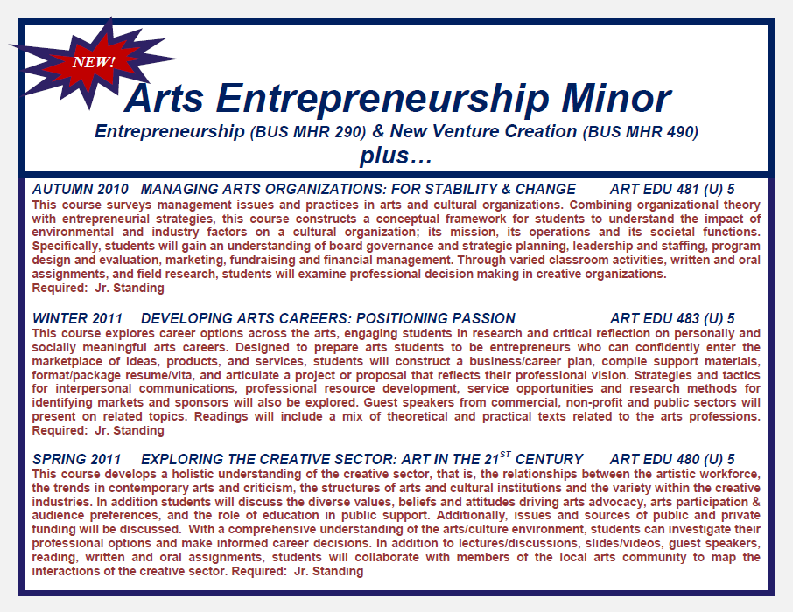

There was a discussion earlier about Bus MHR 490: question whether they wanted to maintain the prereq (Econ 200). It was resolved they would maintain the prereq.
[Note: CAO: Bus MHR 490’s only prereq is Bus MHR 290. According to Rhonda Fisher (Director of the Entrepreneurship Minor and Associate Director of Student Services, FCOB Undergraduate Program): “The 290 prereq was approved over a year ago, but for the 09-10 academic year, we didn't enforce it since all students had not had the opportunity to take it the prior year. For this year we accepted Econ 200, AED Econ 200 or MHR 290. Effective 8/31/2010 only 290 will be the required pre-requisite.”]

- Beyond the minor: possible directions:
  - Policy Focus: Prereq: AE 480
- Public Policy and the Arts
- Creative Sector & Creative Cities
- Managing Cultural Policy Change
- Issues across the Arts (Barnett Symposium)
- Key Policy Issues & Concepts in the Arts
  - Management Focus: Prereq: AE 481
- Arts/Cultural Institutions: Organizational Theory & Management Practice
- Nonprofit Arts Institutions, Governance, and Board Leadership
- Arts Participation, Cultural Programming, and Audience Development
- Arts/Cultural Organizations: Resource Management & Revenue Streams
- Arts/Cultural Mentorships in Management
- Discussion-Q&A
- The courses in the minor are taught out of Fisher & the Dept. of Art Education. Are the 5 courses offered more than once a year? In other words, what would happen in a student missed a course’s offering? A: At this point because of enrollment, the Dept of Art Education offers courses once a year. We are hoping that enrollment might increase and we might offer courses more frequently. The 2 Business courses are doing quite well and are offered several times a year. These are intro courses—much larger student population.
- Since all three art education classes require Junior standing, it could be a very tight fit. A: If many of the 5 courses are taken early, that person can use senior year to fill in the gap.
- It is important that the information about Econ 200 being a prereq to Bus MHR 490 be clear to students because this is a tight schedule. Point this out clearly in advising minor sheet.
- Jane Cataldi would like to clarify the prereq information now because she has several students who are interested in the program right now.
- Is order of these three art education courses important? A: As a personal preference, J. Cataldi believes that it might be better to take Art Ed 480 first, then rest. However, there is no established sequence.
- These will be 3-credit semester courses.
- For the three Art Education courses: plan on adding “permission of instructor.” In the past, sophomores have taken the course & it works well.
- Who is mostly interested in this minor? A: Most students come from College of Arts. Sometimes, Humanities, Fisher, or Public Policy.
- If Arts or Humanities students want to take the minor, is there an access problem? A: No. The Business courses are open courses--i.e. they are accessible to Arts and Humanities students; they are not courses that are designed solely for Business students.
- V. Williams confirms minor has been supported at every stage of its development.
Letter from A&H Subcom stands as motion to approve, 2nd Huffman, unanimously approved

2. Items from Chair
- Approval of Minutes from 3-19-10
- Change wording of resolution to endorse ULAC’s General Education version 2.0 document:
- “CCI endorses (1) the Curricular Experience document and (2) ULAC requirements for semester-based GE with a friendly amendment to clarify that typically it will take 3 courses to satisfy the science requirement.”
- The intent of the authors is: it may be in principle possible to satisfy this requirement with 2 courses in the future Approve the minutes with amendments.
Fredal, 2nd David, unanimously approved
- Folklore Minor Revision (expedited)
- Added several new courses; deleted some courses that are no longer offered or are no longer relevant.
- Language clarification: Add in statement: “Some courses may have pre-requisites. Please consult the course bulletin before enrolling in courses for the minor.”
Huffman, 2nd Fredal, unanimously approved
3. Semester Conversion Update (Terry Gustafson)
- New electronic approval system: PACER (Program and Course Electronic Request Syst). The course portion of PACER will be rolled out as a pilot on May 7 or so. A few units have volunteered to pilot PACER (e.g. Engineering).
- The info content resembles the course template approved by this body a number of months ago.
- There will be an approved spreadsheet for a one-time upload (i.e., they will guarantee that it can be read by this syst.).
- The program approval part will encompass primarily uploads.
- Number 6 (of the 15 questions) does not need to be filled out.
- Fill out information the best you can if you have questions about other units’ offerings. (Make note of your question and go on.)
- We are trying to minimize the number of courses that are going to be entered via spreadsheet. Spreadsheets will be available selectively for units that are not in the pilot. However, it would be better if all units wait until June and use PACER. Indeed, the approved spreadsheet does not contain all the necessary data. The approved spreadsheet is not enough—significant amount of information will still need to be added afterwards. Meanwhile, keep track of information the best way each unit deems (Word document or spreadsheet for now is fine—things will need to be cut and pasted anyway).
- One member wants to make sure that all the information will be available before faculty leave in June. One Department assumes they’ll be able to submit everything to A-Dean on June 1.
- T. Gustafson has met with A-Deans in other colleges and discussed with them how they perceive GE generally. Many units will need to use additional breadth. Minors from other colleges will need to be approved as well by this body. There may be some issues with some minor conversions. So far, there have not been many additional GE courses proposed by other colleges.
- Side note: CAA recently approved a new minor: leadership studies. Not approved by this committee. It was initiated by FAES. After it gets approved by CAA, it will have to come back to CCI if we want our students to be able to take the minor. There is a lot of enthusiasm for the minor by the students.
- Will U/G courses be entered twice once at U and once at G? A: T. Gustafson: 5000-level courses will be both U and G.
- Right now, 500-level courses may provide graduate credit only in other departments. 600-level courses may provide graduate credit (in all departments). Does that distinction apply in the new system? A: T. Gustafson: Maybe 5500 and above will work the same way as 600 works now.
- Will 200-level GEC courses become 2000-level courses? A: G. Mumy: It’s not clear; 367 will become 2367. T. Gustafson: by and large, a number is local. For GEC, CCI may make recommendations one way or the other.
- The document with course numbering system was endorsed by CAA. CCI will receive copies.
- R. Harvey: We are going to start looking at the GEC categories. We‘ll need to add study abroad and service learning. Roundtables for study abroad and service learning will work on draft for expected learning outcomes.
- What is OIA’s and Service Learning Roundtable’s experience with GEC and learning goals? It might be better to ask for their “suggestion”—that would allow CCI to have larger say-so.
- Ad-hoc committee of ASC service learning courses is currently looking at what constitutes a service learning course.
- We’ll also have to look at difference between capstone and cross-disciplinary seminars. This may be a matter of making minor adjustments to the language.
- The combination of international diversity: there may be some minor adjustments too.
- April 23: ASC Faculty Senate will vote on the GE recommendation. Once they approve it, the GE is up and running.
- 3rd writing course is being done away with.
- R. Harvey: How do we want to write/rewrite expected learning outcomes? Divide in subcommittees?
- T. Gustafson: It might be good for all subcommittees to comment on the whole. Review all and focus on the ones pertinent to their field. The intent is to report at the 4-30 CCI meeting. The ASC faculty senate does not vote on expected learning outcomes.

Meeting adjourned 10:30

